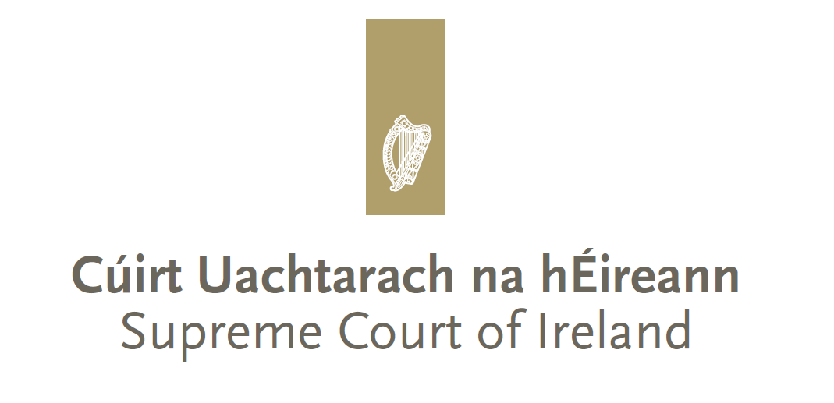

**Comhrá**

*An educational and outreach programme of the Supreme Court of Ireland*

**2025/2026 Application Form**

*Comhrá* (Irish for ‘*conversation*’) is an outreach programme which allows second level students in Ireland to participate in a live question and answer session with judges of the Supreme Court via video-conferencing.

Applications are considered by Courts Service staff working in the Office of the Chief Justice. Factors which are taken into account include the geographical location of the school so we can ensure that schools from all around the country are given the opportunity to participate, and the desirability of ensuring that a substantial proportion of participating schools are drawn from the schools listed under the DEIS (Delivering Equality of Opportunity in Schools) programme. If a school’s application is unsuccessful a school may apply when the next application round opens.

A school selected to participate in the programme will be notified by the Office of the Chief Justice and sent an Information Guide to assist in preparing for the Comhrá.

|  |
| --- |
| Name of school:  Click or tap here to enter text. |
| Coordinating teacher’s name:  Click or tap here to enter text. |
| Email address:Click or tap here to enter text. |
| Contact number of coordinating teacher: Click or tap here to enter text. |
| Name and contact number of staff member assisting with the video call: Click or tap here to enter text. |
| School address: Click or tap here to enter text. |
| School is: Primarily English speaking  Gaeilscoil/Gaelcoláiste  (Sessions generally take place in English but every effort will be made to assign judges proficient in Irish to Comhrá calls with Irish speaking schools) |
| Year or class group from which your particpating students would be drawn: Click or tap here to enter text. |
| Short summary (no more than 200 words) on why the school would like to particpate in the Comhrá programme: |
| The school has the necessary equipment, access to microsoft teams and a reliable internet connection to particpate in the video call. Yes |
| Consent has been given for the Courts Service to take photos and/or record the video call for use in promoting the programme in the future. Any images or recordings will not be used for a purpose beyond promoting the programme. Yes |

**Supreme Court of Ireland**

Four Courts

Inns Quay

Dublin 7

D07 N972

01 888 6540

www.supremecourt.ie